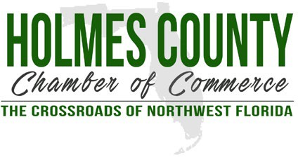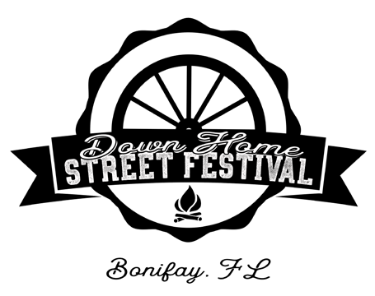
Holmes County Chamber of Commerce 106 E. Byrd Ave, Bonifay, FL 32425 Email: Donna@HolmesChamber.com

CIVIC ORGANIZATION BOOTH APPLICATION
We invite civic and charitable organizations to host a complimentary booth for the purpose of raising awareness of your organization. Fundraising activities will be permitted only with prior approval of event management. Suggested activities include t-shirt sales, games and raffle tickets, fundraising event ticket sales, etc. Food sales may be permitted if they are not in conflict with event food vendor offerings. Please describe your proposed activity in the area provided below.

IMPORTANT!! APPLICATION MUST BE POSTMARKED BY March 1st !!!!
BOOTHS WILL BE OPEN ONLY ON SATURDAY, March 21st
Waiver of liability: Intending to be legally bound. I waive any and all claims of damages from accident, injury or illness that I may suffer as a result of my participation in the 2026 Down Home Street Festival in Bonifay, FL. Further, I agree that the Holmes County Chamber of Commerce, Festival Committee, City of Bonifay or any other group of individuals associated with the conduct of this festival shall not be held responsible for my welfare and I will hold said committee and individuals harmless for same. The festival also reserves the right to decline any application.
Exhibitors must set up between 7-8:30am CT, registration will be located at the street entrance from Hwy 79. Exhibitors can begin to pack up no earlier than 2:15 pm. The street will reopen at 3:00 pm for vendors to enter and exit. No tables, awnings or extension cords will be provided. Due to limited space, only one vehicle per vendor will be allowed in the vendor parking area. Additional vehicles will need to park in the general Festival parking area. If you require handicap parking or some other assistance, please make a note on this form.
ORGANIZATION NAME NAME ADDRESS CITY STATE ZIP TELEPHONE ( ) E-MAIL
Exhibitor’s Signature: DESCRIPTION OF EXHIBIT (FLYERS, GIVEAWAYS, FUNDRAISING, ETC)

